**Batch – 3B**

**NORTHERN ARIZONA UNIVERSITY**

**A PROJECT REPORT**

Submitted in partial fulfilment of the requirements for the award of the degree of

**Bachelor of Technology**

*in*

COMPUTER SCIENCE AND ENGINEERING

**BY**

**KANDULA VARSHINI**

**19331A0572**

**Under the Supervision of Dr. B. SRINIVAS**

(Associate Professor)



**DEPARTMENT OF COMPUTER SCIENCE AND ENGINEERING**

**MVGR COLLEGE OF ENGINEERING (Autonomous)**

**VIZIANAGARAM-535005, AP (INDIA)**

**(Accredited by NBA, NAAC, and Permanently Affiliated to Jawaharlal Nehru Technological University Kakinada)**

**JULY, 2022**

**Maharaj Vijayaram Gajapathi Raj (MVGR) College of Engineering (Autonomous)**

**Vizianagaram**

**CERTIFICATE**





This is to certify that the project report entitled “**NAU ACADEMY**” being submitted by **KANDULA VARSHINI** bearing registered number **19331A0572**, in partial fulfilment for the award of the degree of “**Bachelor of Technology” in Computer Science and Engineering** is a record of bonafide work done by them under my supervision during the academic year 2021-2022.

**HOD CSE Supervisor**

**Dr. Ravi Kiran Varma Dr. B. Srinivas** **Rao**

**(Associate Professor) (AssociateProfessor)**

3

**Acknowledgement**

This project report consumed huge amount of work, research, passion and dedication. In performing this project, we had to take help and guidance of some respected people, who deserve our greatest gratitude.

We would like to express our deep gratitude to our project guide Dr. B. Srinivas Rao, Professor, Department of Computer Science and Engineering, MVGR College of Engineering, for his guidance with unsurpassed knowledge and immense encouragement.

We would like to thank our parents, friends, and classmates for their encouragement throughout our project period. At last but not the least, we thank everyone for supporting us directly or indirectly in completing this project successfully.

**Table of Contents**

**Contents :**

|  |  |  |
| --- | --- | --- |
|  | **ABSTRACT** | **5** |
|  | **INTRODUCTION** | **7** |
|  | **METHODOLOGY** | **8** |
|  | **DESIGN AND IMPLEMENTATION** | **22** |
|  | **EXPERIMENTAL RESULTS (OUTPUT)** | **27** |
|  | **CONCLUSION** | **28** |
|  | **PROJECT OUTCOME** | **29** |
|  |  |  |
|  | **REFERENCES** | **30** |

**ABSTRACT**

NAU aims to be the nation's preeminent engine of opportunity, vehicle of economic mobility, and driver of social impact by delivering equitable postsecondary value in Arizona and beyond.

This application provides NAU Academy website. This application also helps how the NAU academy website is developed. Information about the NAU academy is provided in this document. To apply and to register or to know the details about NAU academy is provided.It is an interface or a medium to interact/contact with NAU academy. Contact form and Location details are provided.

**NAU began as a teachers’ college, and our commitment to building a better tomorrow through education remains our highest priority. Our students, mentored by faculty members who are renowned in their fields, are at the center of all we do.**

In the classroom and online, through hands-on experiences in an unparalleled learning environment, and with the NAU community cheering them on, our students discover and hone their ambitions.

University College was a portal for students to make efficient, informed decisions about pursuing academic paths. Undergraduate students automatically became a part of University College when admitted to Northern Arizona University. Various programs, resources, and support included academic transition programs, the First Year Learning Initiative, and the Bachelor of University Studies degree program. NAU is home to the first Honors program offered in Arizona. The academic enrichment program is open to students of all majors and offers coursework, research opportunities, and programs designed to enhance the undergraduate experience. Honors College students have unique opportunities for study abroad and can participate in out-of-classroom programs like Canyon Country Aesthetics. Freshman Honors students can live in the Honors Residence College, which offers living, learning, and study spaces under the same roof.

# 1.INTRODUCTION

This Web based Application (Dynamic) is a Resource Management Tool for a college in which Registrations, Authentications(Logins) are embedded. The website is Opensource and the one who has login rights are permitted to upload the Documents and all others have access to the content they Uploaded.

Here we used HTML, CSS, bootstrap to develop a frontend website. The Hyper Text Markup Language, or HTML is the standard markup language for documents designed to be displayed in a web browser. It can be assisted by technologies such as Cascading Style Sheets (CSS) and scripting languages such as JavaScript. CSS is the language we use to style an HTML document. CSS describe show HTML elements should be displayed. Quickly design and customize responsive mobile-first sites with Bootstrap, the world’s most popular front-end open source tool kit, featuring Sass variables and mixing, responsive grid system, extensive pre built components, and powerful JavaScript plugins. JavaScript is the programming language of the Web.

**HTML:**

The Hyper Text Markup Language or HTML is the standard markup language for documents designed to be displayed in a web browser. It can be assisted by technologies such as Cascading Style Sheets (CSS) and scripting languages such as JavaScript.

Web browsers receive HTML documents from a web server or from local storage and render the documents into multimedia web pages. HTML describes the structure of a web page semantically and originally included cues for the appearance of the document.

HTML elements are the building blocks of HTML pages. With HTML constructs, images and other objects such as interactive forms may be embedded into the rendered page. HTML provides a means to create structured documents by denoting structural semantics for text such as headings, paragraphs, lists, links, quotes and other items. HTML elements are delineated by tags, written using angle brackets. Tags such as <img /> and <input /> directly introduce content into the page. Other tags such as <p> surround and provide information about document text and may include other tags as sub-elements. Browsers do not display the HTML tags but use them to interpret the content of the page.

## **Template**

A template is a file where you describe how the result should be represented.

Templates are often .html files, with HTML code describing the layout of a web page, but it can also be in other file formats to present other results, but we will concentrate on .html files.

**CSS:**

* CSS stands for Cascading Style Sheets
* CSS describes how HTML elements are to be displayed on screen, paper, or in other media
* CSS saves a lot of work. It can control the layout of multiple web pages all at once
* External stylesheets are stored in CSS files.
* There are three types of CSS which are given below:
* Inline CSS.
* Internal or Embedded CSS.
* External CSS.

Here in this project inline CSS is used :

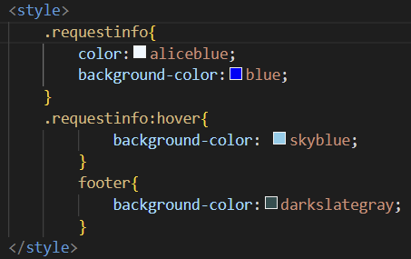

Fig (1.1)

Presentation of the code (adding CSS)

# 2.METHODOLOGY

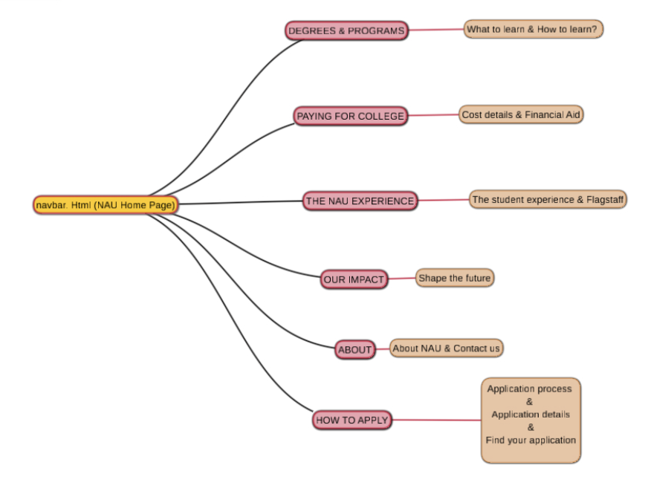

# Fig (2.1)

# Model on how to apply and application details

# 

# 3.DESIGN AND IMPLEMENTATION

## 

# Here we created multiple pages with navbar.html as a main page. With “assets” having all the CSS, Images and Java script files. And navbar.html contains Path to other directories in the code. Here we used languages like:

# Front-end: HTML, CSS, JavaScript, Bootstrap Home Page: navbar.html

# Jpg files : Icons and images used to add images to Hoem page.

# We use page referencing and html tags for page design and CSS for page styling and JavaScript for Page back-end implementation and BOOTSTRAP for Dynamic Page Designing.

## System Requirements

Operating System :Windows , Mac , Linux

SDK : GitHub, VS-Code (any Editor)

## Hardware Requirements

RAM : Minimum 8GB

GPU: 4GB dedicated

Processor: Intel Pentium 4 or higher HDD: 10GB or higher

Monitor: 15” or 17” color monitor

Mouse: Scroll or Optical Mouse or Touch Pad Keyboard: Standard 110 keys keyboard

**Technologies or modules involved:**

# Front-end: HTML, CSS, JavaScript, Bootstrap

# Home Page: navbar.html

# CODE :-

# NAVBAR.HTML

# <!DOCTYPE html>

# <html>

# <head>

# <link rel="stylesheet" href="https://cdn.jsdelivr.net/npm/bootstrap@4.3.1/dist/css/bootstrap.min.css" integrity="sha384-ggOyR0iXCbMQv3Xipma34MD+dH/1fQ784/j6cY/iJTQUOhcWr7x9JvoRxT2MZw1T" crossorigin="anonymous">

# <style>

# .requestinfo{

# color:aliceblue;

# background-color:blue;

# }

# .requestinfo:hover{

# background-color: skyblue;

# }

# footer{

# background-color:darkslategray;

# }

# </style>

# </head>

# <body>

# <nav class="navbar navbar-light bg-light">

# <a class="navbar-brand"><img src="C:\sem 6\wt_pbl\Nau_icon1.JPG" height="50" width="250"></a>

# <form class="form-inline">

# <div class="nav1">

# <a class="research" href="https://nau.edu/legacy/research/">Research&nbsp;&nbsp;</a>

# <a class="athletics" href="https://nauathletics.com/">Athletics&nbsp;&nbsp; </a>

# <a class="alumni" href="https://www.foundationnau.org/s/1898/custom19/home.aspx?gid=2">Alumni&nbsp;&nbsp; </a>

# <a class="giving" href="https://securelb.imodules.com/s/1898/giving19/landing.aspx?sid=1898&gid=2&pgid=672&cid=1127">Giving&nbsp;&nbsp; </a>

# <a class="locations" href="https://nau.edu/about/locations-and-maps/">Locations &nbsp;&nbsp;</a>

# </div>

# <label style="color:blue">QUICK LINK :&nbsp;</label>

# <select><a class="nav-link dropdown-toggle" href="" id="navbarDropdownMenuLink" data-toggle="dropdown" aria-haspopup="true" aria-expanded="false"></a>

# 

# <li class="nav-item dropdown" list-style-type: none;></li>

# <div class="dropdown-menu" aria-labelledby="navbarDropdownMenuLink">

# <option><a href="https://nau.edu/">NAU Home</a></option>

# <option><a href="https://nau.edu/how-to-apply/undergraduate/">Academics</a></option>

# <option><a href="https://nau.edu/legacy/admissions/">Admissions</a></option>

# <option><a href="https://nau.edu/about/locations-and-maps/">Campus Life</a></option>

# <option><a href="https://nau.edu/legacy/research/">Research</a></option>

# <option><a href="https://nauathletics.com/">Athletics</a></option>

# <option><a href="https://nau.edu/about/">About NAU</a></option>

# <option><a href="https://securelb.imodules.com/s/1898/giving19/landing.aspx?sid=1898&gid=2&pgid=672&cid=1127">Give</a></option>

# <option><a href="https://nau.edu/library">Library</a></option>

# <option><a href="https://nau.edu/legacy/department-index/">A-Z Library</a></option>

# <option><a href="https://cas.nau.edu/cas/login?service=https%3A%2F%2Fshibboleth.nau.edu%2Fidp%2FAuthn%2FRemoteUser%3Fconversation%3De1s1">My.NAU.edu</a></option>

# <option><a href="https://cas.nau.edu/cas/login?service=https%3A%2F%2Fshibboleth.nau.edu%2Fidp%2Fgoogleprofile%2FSAML2%2FRedirect%2FSSO%3FSAMLRequest%3DfVLJTsMwEL0j8Q%252BW71kPqFhNUAEhKrFENOXAzXUmiYtjB4%252Fdwt%252BTpq0oB7g%252Bv3nLeKZXn50iG7Aojc5oEsaUgBamkrrJ6LK8Cyb0Kj8%252FmyLvVM9m3rX6BT48oCPDpEY2PmTUW80MR4lM8w6QOcEWs8cHloYx661xRhhFyfw2o30tdNWp96ozhsNK1%252Bu2lbqum7aXct037apem3dYU%252FJ6jJXuYs0RPcw1Oq7dAMVpGsQXQXJZJimLE5ZM3igpDk7XUu8b%252FBdrtSchuy%252FLIiieF%252BUosJEV2KeBndHGmEZBKEy3sy84otwMcM0VAiUzRLBuCHhjNPoO7ALsRgpYvjxktHWuRxZF2%252B02%252FJGJeKS5D6HyERdI83GtbGxmT%252Fb5f25%252B9KX5j%252FI0OpHKD9%252B1azG%252FLYyS4ovMlDLbGwvcDRWc9UODO2M77v52S8JkRGQV1COVeY09CFlLqCiJ8r3r77sYruUb%26RelayState%3Dhttps%253A%252F%252Fwww.google.com%252Fa%252Fnau.edu%252FServiceLogin%253Fservice%253Dmail%2526passive%253Dtrue%2526rm%253Dfalse%2526continue%253Dhttps%25253A%25252F%25252Fmail.google.com%25252Fmail%25252F%2526ss%253D1%2526ltmpl%253Ddefault%2526ltmplcache%253D2%2526emr%253D1%2526osid%253D1">Student Webmail</a></option>

# <option><a href="https://iris.nau.edu/owa/auth/logon.aspx?replaceCurrent=1&url=https%3a%2f%2firis.nau.edu%2fowa%2f">Faculty/Staff Webmail</a></option>

# <option><a href="">LOUIE</a></option>

# <option><a href="">Catalog</a></option>

# <option><a href="">JacksCard</a></option>

# <option><a href="">Bb Learn</a></option>

# <option><a href="">PL Student Dashboard</a></option>

# <option><a href="">Grades & Transcripts</a></option>

# </div>

# </li>

# </select>

# </nav>

# <nav class="navbar navbar-dark bg-dark">

# <a class="degrees" href="" style="color:white">Degrees & Programs </a>

# <a class="pay" href="" style="color:white";>Paying for college </a>

# <a class="exp" href="" style="color:white">The NAU Experience </a>

# <a class="impact" href="" style="color:white">Our Impact </a>

# <a class="about" href="" style="color:white">About </a>

# <a alert(href="C:\sem 6\wt_pbl\searchcode.html");><button class="search_icon" type="submit" ><img src="C:\sem 6\wt_pbl\search_icon.JPG" height="25" width="25"></a></button>

# <label style="color:white;">How to apply :</label>

# <select><a class="nav-link dropdown-toggle" href="" id="navbarDropdownMenuLink" data-toggle="dropdown" aria-haspopup="true" aria-expanded="false"></a>

# 

# <li list-style-type: none;></li>

# <div aria-labelledby="navbarDropdownMenuLink">

# <option><a href="">Apply Now</a></option>

# <option><a href="">How to apply</a></option>

# <option><a href="">Request Information</a></option>

# <option><a href="">First-year LUMVERJACKS</a></option>

# <option><a href="">Graduate students</a></option>

# <option><a href="">Non-degree-seeking students</a></option>

# <option><a href="">International students</a></option>

# <option><a href="">Transfer students</a></option>

# </div>

# </li>

# </select>

# </nav>

# <frameset rows="70%,10%,20%">

# <center>

# <br>

# <br>

# <br>

# <iframe src="C:\sem 6\wt_pbl\frame1.jpg" height="400" width="600" frameborder="0"></iframe>

# <br>

# </center>

# <frame>

# <a href="https://nau.edu/">NAU</a> >

# <a href="https://nau.edu/about/locations-and-maps/"> Location</a> > Northland Pioneer College

# </frame>

# </frameset>

# <frame>

# <br>

# <br>

# <br>

# <center>

# <h1 style="color:navy;"><b>Northland Pioneer College</b></h1>

# </center>

# <br>

# <br>

# </frame>

# <iframe src="https://www.google.com/maps/embed?pb=!1m18!1m12!1m3!1d3298.215495212924!2d-110.05580718484929!3d34.24304448055439!2m3!1f0!2f0!3f0!3m2!1i1024!2i768!4f13.1!3m3!1m2!1s0x872f335afd3ee9f7%3A0xe844ff233c7f6f58!2sNorthland%20Pioneer%20College!5e0!3m2!1sen!2sin!4v1655639228572!5m2!1sen!2sin" width="1500" height="450" style="border:0;" allowfullscreen="" loading="lazy" referrerpolicy="no-referrer-when-downgrade"></iframe>

# <frameset cols="35%,65%">

# <iframe src="C:\sem 6\wt_pbl\contactus.html" width="250" height="800"></iframe>

# <iframe src="C:\sem 6\wt_pbl\location.html" width="1250" height="800"></iframe>

# </frameset>

# <footer>

# <frameset cols="50%,50%">

# <iframe src="C:\sem6\wt_pbl\footer_left.html" width="750" height="550" ></iframe>

# <iframe src="C:\sem6\wt_pbl\footer_right.html" width="750" height="550"></iframe>

# </frameset>

# </footer>

# <footer>

# <div>

# <section>

# &nbsp;&nbsp;&nbsp;&nbsp;&nbsp;&nbsp;&nbsp;&nbsp;&nbsp;&nbsp;&nbsp;&nbsp;&nbsp;&nbsp;&nbsp;&nbsp;&nbsp;&nbsp;&nbsp;

# <img src="C:\sem 6\wt_pbl\Nau_icon1.JPG" height="70" width="250">

# &nbsp;&nbsp;&nbsp;&nbsp;&nbsp;&nbsp;&nbsp;&nbsp;&nbsp;&nbsp;&nbsp;&nbsp;&nbsp;&nbsp;&nbsp;&nbsp;&nbsp;&nbsp;&nbsp;

# &nbsp;&nbsp;&nbsp;&nbsp;&nbsp;&nbsp;&nbsp;&nbsp;&nbsp;&nbsp;&nbsp;&nbsp;&nbsp;&nbsp;&nbsp;&nbsp;&nbsp;&nbsp;&nbsp;

# &nbsp;&nbsp;&nbsp;&nbsp;&nbsp;&nbsp;&nbsp;&nbsp;&nbsp;&nbsp;&nbsp;&nbsp;&nbsp;&nbsp;&nbsp;&nbsp;&nbsp;&nbsp;&nbsp;

# &nbsp;&nbsp;&nbsp;&nbsp;&nbsp;&nbsp;&nbsp;&nbsp;&nbsp;&nbsp;&nbsp;&nbsp;&nbsp;&nbsp;&nbsp;&nbsp;&nbsp;&nbsp;&nbsp;

# &nbsp;&nbsp;&nbsp;&nbsp;&nbsp;&nbsp;&nbsp;&nbsp;&nbsp;&nbsp;&nbsp;&nbsp;&nbsp;&nbsp;&nbsp;&nbsp;&nbsp;&nbsp;&nbsp;

# &nbsp;&nbsp;&nbsp;&nbsp;&nbsp;&nbsp;&nbsp;&nbsp;&nbsp;&nbsp;&nbsp;&nbsp;&nbsp;&nbsp;&nbsp;&nbsp;&nbsp;&nbsp;&nbsp;

# &nbsp;&nbsp;&nbsp;&nbsp;&nbsp;&nbsp;&nbsp;&nbsp;&nbsp;&nbsp;&nbsp;&nbsp;&nbsp;&nbsp;&nbsp;&nbsp;&nbsp;&nbsp;&nbsp;

# <button type="submit" onclick=""><img src="C:\sem 6\wt_pbl\fb.jpg" height="30" width="30"></button>

# &nbsp;&nbsp;&nbsp;&nbsp;&nbsp;&nbsp;&nbsp;&nbsp;&nbsp;&nbsp;&nbsp;&nbsp;&nbsp;&nbsp;&nbsp;&nbsp;&nbsp;&nbsp;&nbsp;

# <button type="submit" onclick=""><img src="C:\sem 6\wt_pbl\tweet.jpg" height="30" width="30"></button>

# &nbsp;&nbsp;&nbsp;&nbsp;&nbsp;&nbsp;&nbsp;&nbsp;&nbsp;&nbsp;&nbsp;&nbsp;&nbsp;&nbsp;&nbsp;&nbsp;&nbsp;&nbsp;&nbsp;

# <button type="submit" onclick=""><img src="C:\sem 6\wt_pbl\insta.jpg" height="30" width="30"></button>

# &nbsp;&nbsp;&nbsp;&nbsp;&nbsp;&nbsp;&nbsp;&nbsp;&nbsp;&nbsp;&nbsp;&nbsp;&nbsp;&nbsp;&nbsp;&nbsp;&nbsp;&nbsp;&nbsp;

# <button type="submit" onclick=""><img src="C:\sem 6\wt_pbl\in.jpg" height="30" width="30"></button>

# &nbsp;&nbsp;&nbsp;&nbsp;&nbsp;&nbsp;&nbsp;&nbsp;&nbsp;&nbsp;&nbsp;&nbsp;&nbsp;&nbsp;&nbsp;&nbsp;&nbsp;&nbsp;&nbsp;

# </section>

# </div>

# </footer>

# </body>

# </html>

# FOOTER.HTML

# <!DOCTYPE html>

# <html>

# <body>

# <img src="C:\sem 6\wt_pbl\Nau_icon1.JPG" height="100" width="200">

# </body>

# </html>

# FOOTER_LEFT.HTML

# <!DOCTYPE html>

# <head>

# <style>

# .b1{

# background-color:yellow;

# }

# </style>

# </head>

# <html>

# <body>

# <center>

# <table bgcolor="rgb(0, 139, 139)" width="700" height="500">

# <br>

# <tr>

# <th><h3 style="color:white"><b>Campus locator</b></h3></th>

# <th><h4 style="color:white"><b>FLAGSTAFF</b></h4></th>

# </tr>

# <tr>

# <td>

# <label style="color:white;">SELECT A LOCATION;<br></label>

# <br>

# <select>

# <option><a href="">Central Arizona College</a></option>

# <option><a href="">Chandler-Gilbert Community College</a></option>

# <option><a href="">Cochise College</a></option>

# <option><a href="">Coconino Community College</a></option>

# <option><a href="">Eastern Arizona College</a></option>

# <option><a href="">Flagstaff</a></option>

# <option><a href="">Gateway Community College</a></option>

# <option><a href="">Glendale Community College</a></option>

# <option><a href="">Mesa Community College</a></option>

# </select>

# </td>

# </tr>

# <tr>

# <td><br></td>

# <td>

# <p style="color:white;">Northland Pioneer College<br>

# 1001 W Deuce of Clubs<br>

# Show Low AZ 85902-3411</p>

# <p><a href="" style="color:white;">928-523-5398</a></p>

# <a href="https://nau.edu/about/locations-and-maps/"><button type="submit" onclick="" class="b2">View all<br> Locations</a></button>

# <a href="https://nau.edu/location/nau-flagstaff-campus/"><button type="submit" onclick="" class="b1">View<br> Campus Info</a></button>

# </td>

# </tr>

# </table>

# </center>

# </body>

# </html>

# FOOTER_RIGHT.HTML

# <!DOCTYPE html>

# <html>

# <head>

# <style>

# a{

# color:white;

# }

# </style>

# </head>

# <body>

# <center>

# <table bgcolor="rgb(0, 139, 139)" width="700" height="0">

# <br>

# <tr>

# <th><b><h3 style="color:white;">Resources&nbsp;&nbsp;&nbsp;&nbsp;&nbsp;&nbsp;&nbsp;&nbsp;&nbsp;&nbsp;&nbsp;</h2></b></h2></th>

# <th><b><h3 style="color:white;">Policies</h2></b></h2></th>

# </tr>

# <tr>

# <td>

# <p><a href="https://in.nau.edu/accessibility/aira/">Aria</a></p>

# <p><a href="https://bblearn.nau.edu/"> BbLearn</a></p>

# <p><a href="https://iris.nau.edu/owa/auth/logon.aspx?replaceCurrent=1&url=https%3a%2f%2firis.nau.edu%2fowa">Faculty/Staff Login</a></p>

# <p><a href="https://cas.nau.edu/cas/login?service=https%3A%2F%2Fshibboleth.nau.edu%2Fidp%2Fgoogleprofile%2FSAML2%2FRedirect%2FSSO%3FSAMLRequest%3DfVJNT%252BMwEL2vxH%252BwfE%252FSBIR2rSaogBCV2CWigQM3x5kkJo4dPHa7%252FHvcFAQc4Pr85n2MZ3n2f1RkCxal0TlN4wUloIVppO5yel9dRb%252FpWXH0a4l8VBNbedfrO3j2gI6ESY1sfsipt5oZjhKZ5iMgc4JtVn9vWBYv2GSNM8IoStaXOe3rWvBmGDrV13ocghnwQfVN209ieBJa1dPYt31HycN7rGwfa43oYa3Rce0CtMiyaHEapX%252Bq9JilKTvJHikp35zOpT40%252BClWfSAhu66qMipvN9UssJUN2H%252BBndPOmE5BLMy4ty85otwGuOUKgZIVIlgXAl4YjX4EuwG7lQLu725CS%252BcmZEmy2%252B3iD5mEJ5r7GBqfcIG0mNfK5mb20z5%252Fzs3ffWnxobxMPkkVb9%252B1b7G%252BLI2S4oWslDK7CwvchQrO%252BtDgytiRu%252B%252Fd0jidEdlE7UxlXuMEQrYSGkqS4uD69S7CtbwC%26RelayState%3Dhttps%253A%252F%252Fwww.google.com%252Fa%252Fnau.edu%252FServiceLogin%253Fservice%253Dmail%2526passive%253Dtrue%2526rm%253Dfalse%2526continue%253Dhttps%25253A%25252F%25252Fmail.google.com%25252Fmail%25252F%2526ss%253D1%2526ltmpl%253Ddefault%2526ltmplcache%253D2%2526emr%253D1%2526osid%253D1">Student gmail</a></p>

# <p><a href="https://www.peoplesoft.nau.edu/n__maintenance.jsp">LOUIE</a></p>

# <p><a href="https://cas.nau.edu/cas/login?service=https%3A%2F%2Fshibboleth.nau.edu%2Fidp%2FAuthn%2FRemoteUser%3Fconversation%3De1s1">my.NAU.edu</a></p>

# <p><a href="https://nau.edu/library/">Cline Library</a></p>

# <p><a href="https://in.nau.edu/emergency-management/">Emergency information</a></p>

# <p><a href="https://in.nau.edu/human-resources/current-job-openings/">Jobs at NAU</a></p>

# <p><a href="https://in.nau.edu/registrar/important-dates/">Academic calender</a></p>

# <p><a href="https://nau.edu/legacy/maps">Maps</a></p>

# <p><a href="https://nau.edu/sitemap">Site Map</a></p>

# 

# </td>

# <td>

# <p><a href="https://in.nau.edu/Accessibility/Policies/" style="color:white;">Accessibility</a></p>

# <p><a href="https://in.nau.edu/center-for-university-access-and-inclusion/diversity-strategic-plan-overview/" style="color:white;">Diversity</a></p>

# <p><a href="https://in.nau.edu/eao/" style="color:white;">Equity & access</a></p>

# <p><a href="https://in.nau.edu/hipaa/" style="color:white;">Privacy</a></p>

# <p><a href="https://in.nau.edu/institutional-research/higher-education-act/" style="color:white;">Student consumer info</a></p>

# <p><a href="https://nau.edu/university-policy-library/" style="color:white;">University policy library</a></p>

# <p><a href="https://in.nau.edu/title-ix/" style="color:white;">Title IX</a></p>

# </td>

# </tr>

# </table>

# </center>

# </body>

# </html>

# LOCATION.HTML

# <!DOCTYPE html>

# <html>

# <head>

# <style>

# .see{

# color:black;

# float:right;

# }

# .see:hover{

# background-color: skyblue;

# }

# </style>

# </head>

# <body>

# 

# <br>

# <br>

# <img src="C:\sem 6\wt_pbl\loc_offerhrs.jpg">

# <br>

# <br>

# <h2 style="color:navy;"><b>Location Information</b></h2>

# <p style="color:navy;">NAU at NPC is one of our many statewide locations. Learn close to home while accessing the same high-quality education, faculty mentorship, and student-centered experience that NAU has cultivated for more than 100 years—and earn the same nationally renowned, fully accredited degree when you graduate.</p>

# <a href="https://degree-search.nau.edu/search?campus=SHWLW"><button type="submit" class="see">See all degrees at this location<img src="C:\sem 6\wt_pbl\buttonside.jpg" width="10" height="10"></a></button>

# <h2 style="color:navy;"><b>Location Resources</b></h2>

# <table>

# <tr>

# <th><img src="C:\sem 6\wt_pbl\accessibility.jpg"></i>">Accessibility</th>

# <th><img src="C:\sem 6\wt_pbl\NAUbookstore.jpg">NAU Bookstore</th>

# </tr>

# <tr>

# <td>

# <p style="color:navy;">This campus is <a href="https://in.nau.edu/disability-resources/"><u>accessible</u></a> to students with disabilities&nbsp;&nbsp;&nbsp;&nbsp;&nbsp;</p>

# </td>

# <td>

# <p>&nbsp;&nbsp;&nbsp;<a href="https://www.bkstr.com/northernarizonastore/home"><u> Flagstaff Bookstore</u></a></p>

# <p style="color:navy;">&nbsp;&nbsp;&nbsp;&nbsp;&nbsp;928-523-6691</p>

# </td>

# </tr>

# </table>

# <h1 style="color:navy;"><b>2NAU Pathway Program</b></h1>

# <p style="color:navy;">The 2NAU pathway program was developed through partnerships between NAU and the Arizona community colleges. This program provides you with a seamless path to earn an affordable and respected NAU bachelor’s degree. You will begin your coursework at your community college, then transfer to NAU in Flagstaff, Online, or to one of our Statewide locations to finish your degree.

# We recommend signing up for this program at least two semesters before you are ready to transfer to maximize the benefits including a merit-based scholarship.</p>

# <a href="https://nau.edu/admission/2nau-admission/"><button type="submit" class="see" onclick="">Additional information and participation form<img src="C:\sem 6\wt_pbl\buttonside.jpg" width="10" height="10"></a></button>

# </body>

# </html>

# CONTACTUS.HTML

# <!DOCTYPE html>

# <head>

# <style>

# .requestinfo{

# color:aliceblue;

# background-color:blue;

# }

# .requestinfo:hover{

# background-color: skyblue;

# }

# </style>

# </head>

# <html>

# <body>

# <h4><b><u>Contact Us</u></b></h4>

# <a href=""><img src="C:\sem 6\wt_pbl\phn_icon.jpg">928-523-5398</a>

# <br>

# <a href=""><img src="C:\sem 6\wt_pbl\mail_icon.jpg">showlow@nau.edu</a>

# <br>

# <br>

# <a href="https://nau.edu/legacy/request-information/"><button type="Submit" class="requestinfo" >Request Info</button></a>

# <br>

# <br>

# </body>

# </html>

# SEARCHCODE.HTML

# <!DOCTYPE html>

# <html>

# <body>

# <div class="input-group">

# <div class="form-outline">

# <input type="search" id="form1" class="form-control" />

# <label class="form-label" for="form1">Search</label>

# </div>

# <button type="button" class="btn btn-primary">

# <i class="fas fa-search"></i>

# </button>

# </div>

# </body>

# </html>

**CODE LOCATION :**

**GITHUB :** [**https://github.com/Kantubhukta-Hemanth/varshini**](https://github.com/Kantubhukta-Hemanth/varshini)

**DEPLOYEMENT :** [**https://mvgr-cache.herokuapp.com/**](https://mvgr-cache.herokuapp.com/)

**4.EXPERIMENTAL RESULTS (OUTPUT)**

**navbar.html(HOME)**

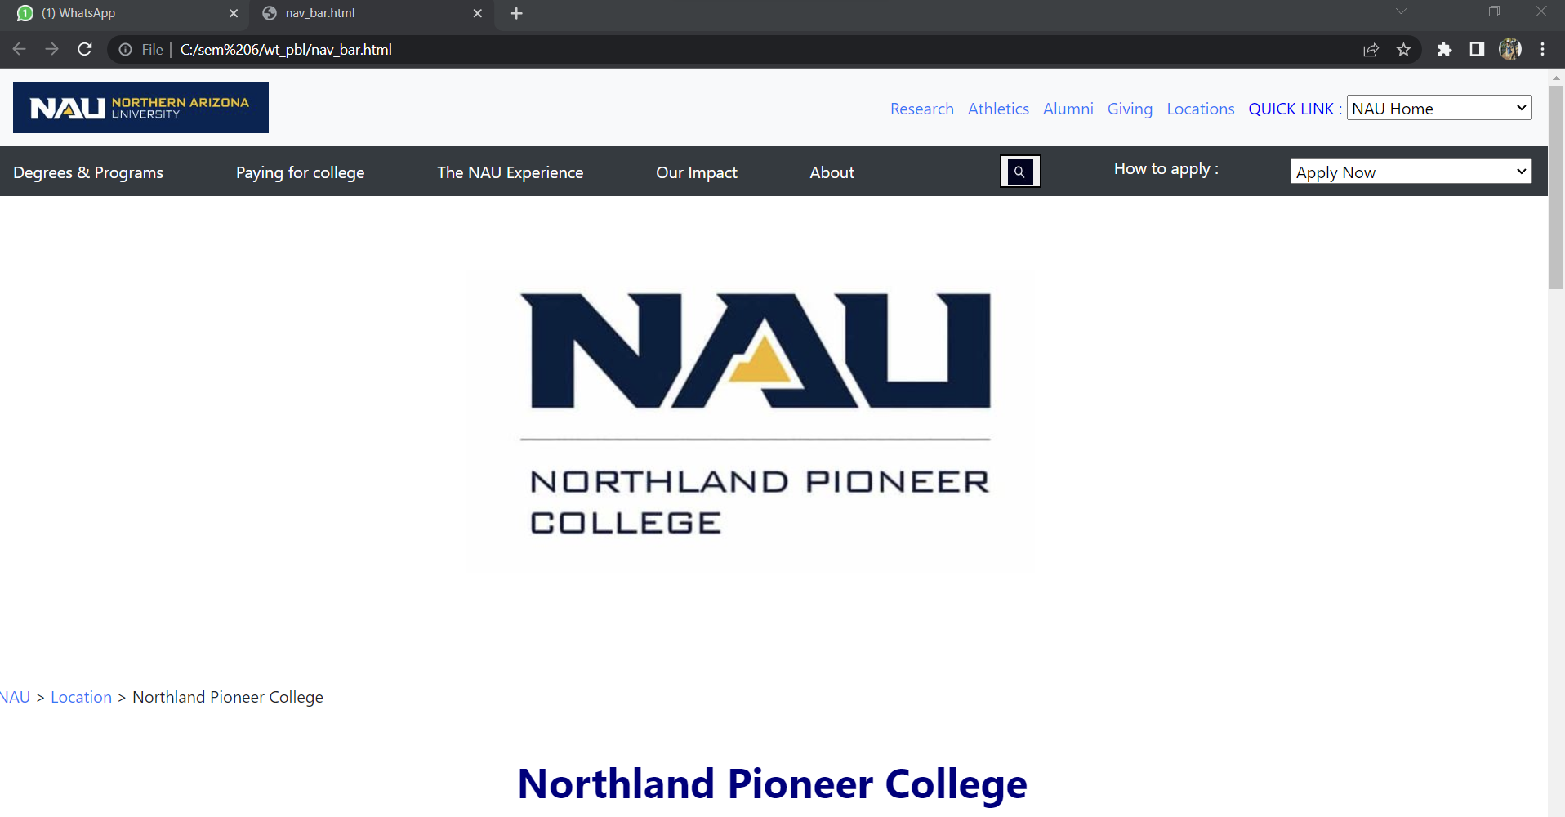

Fig (4.1)

**Location.html**

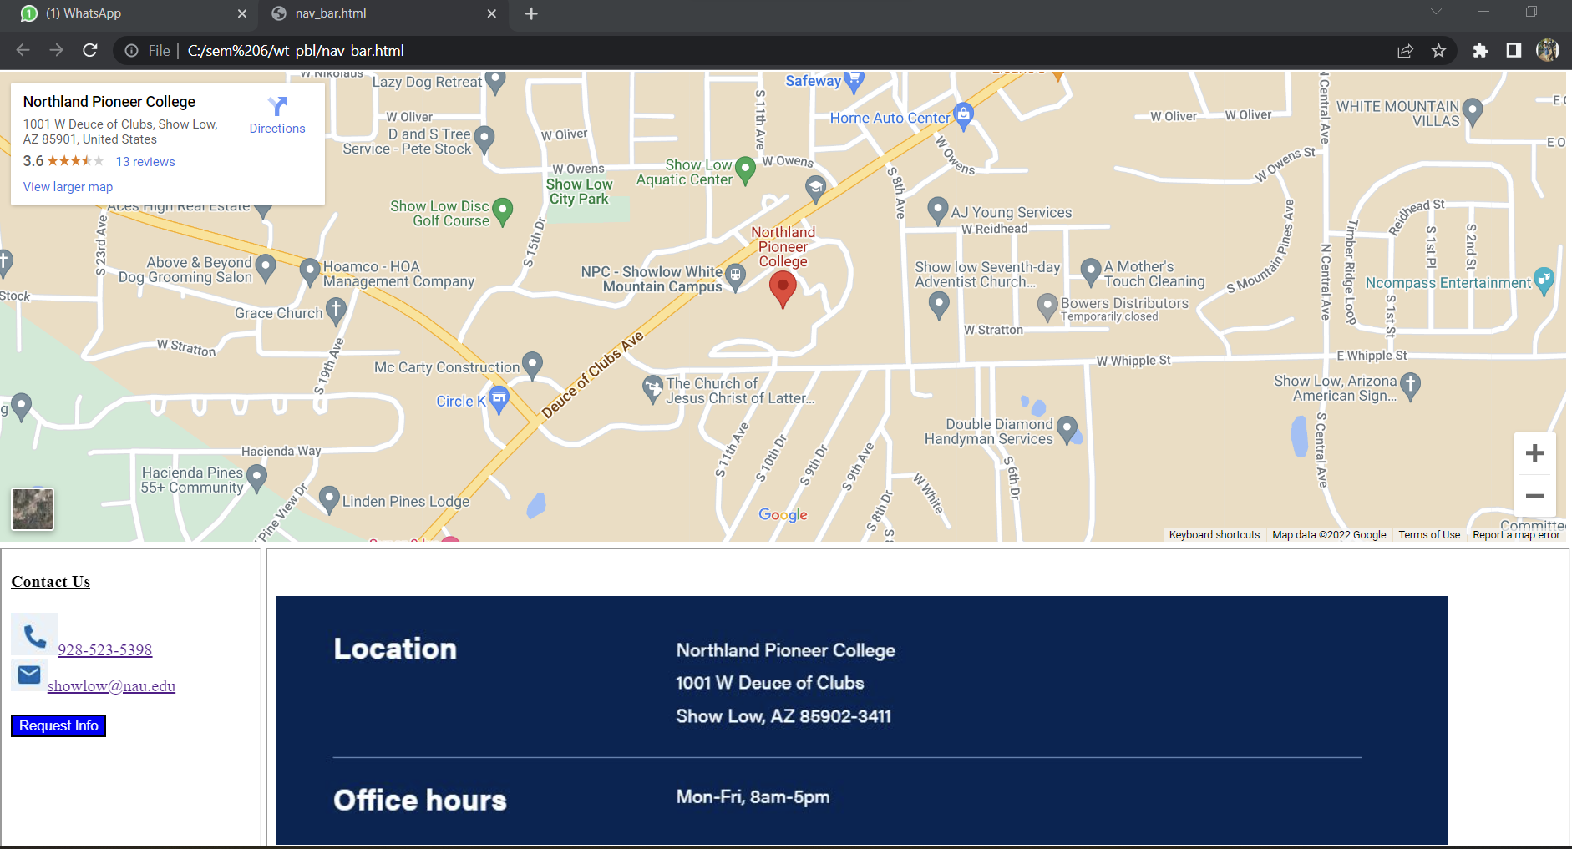

Fig (4.2)

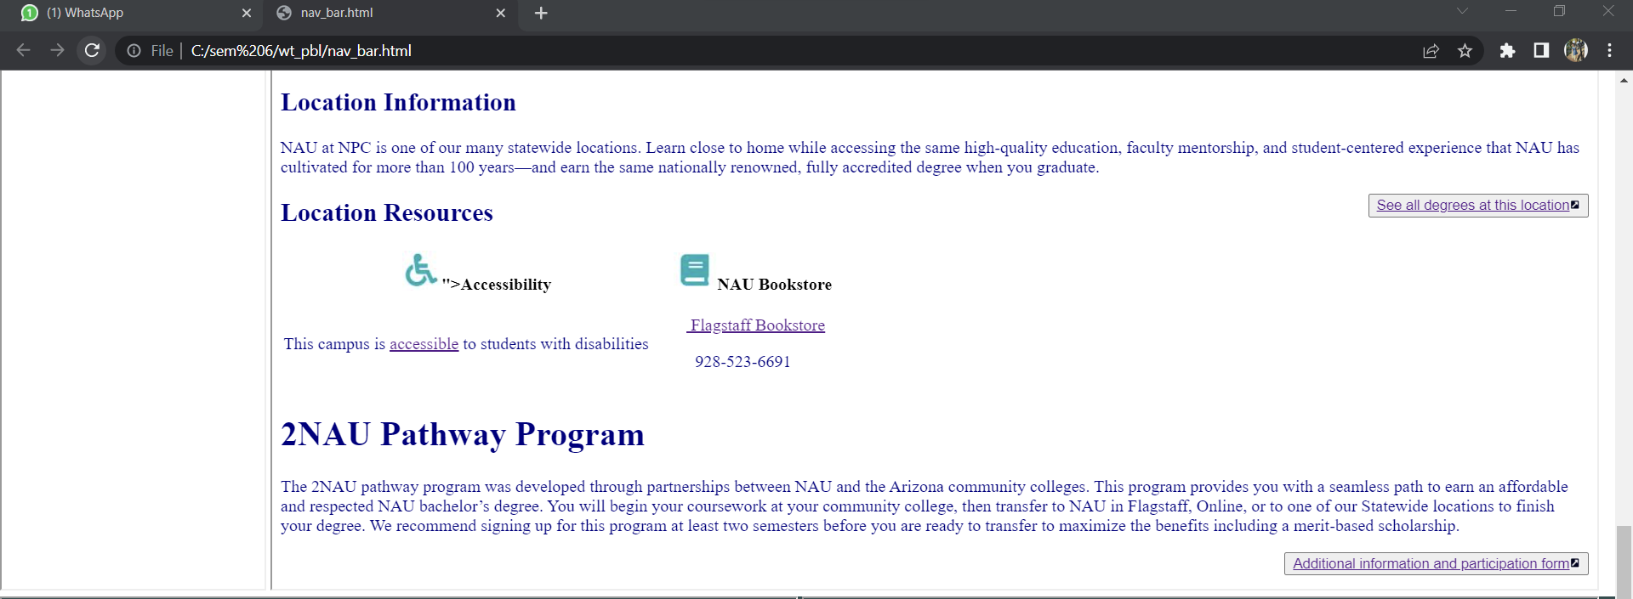

Fig (4.3)

**Footer_right.html & Footer_left.html**

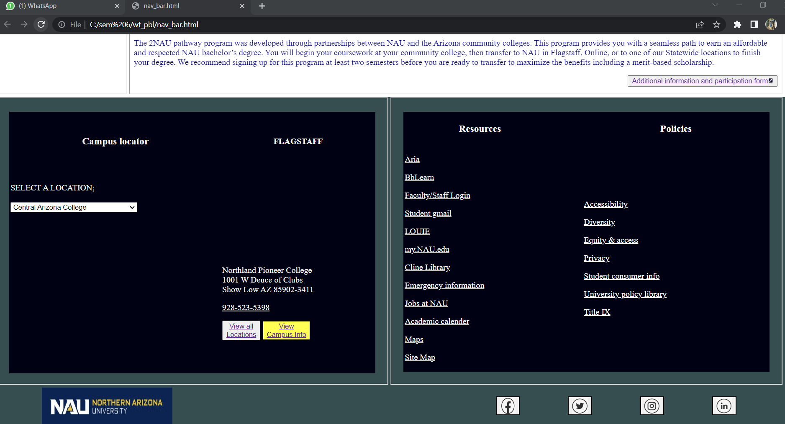

Fig (4.4)

**NAU Location**

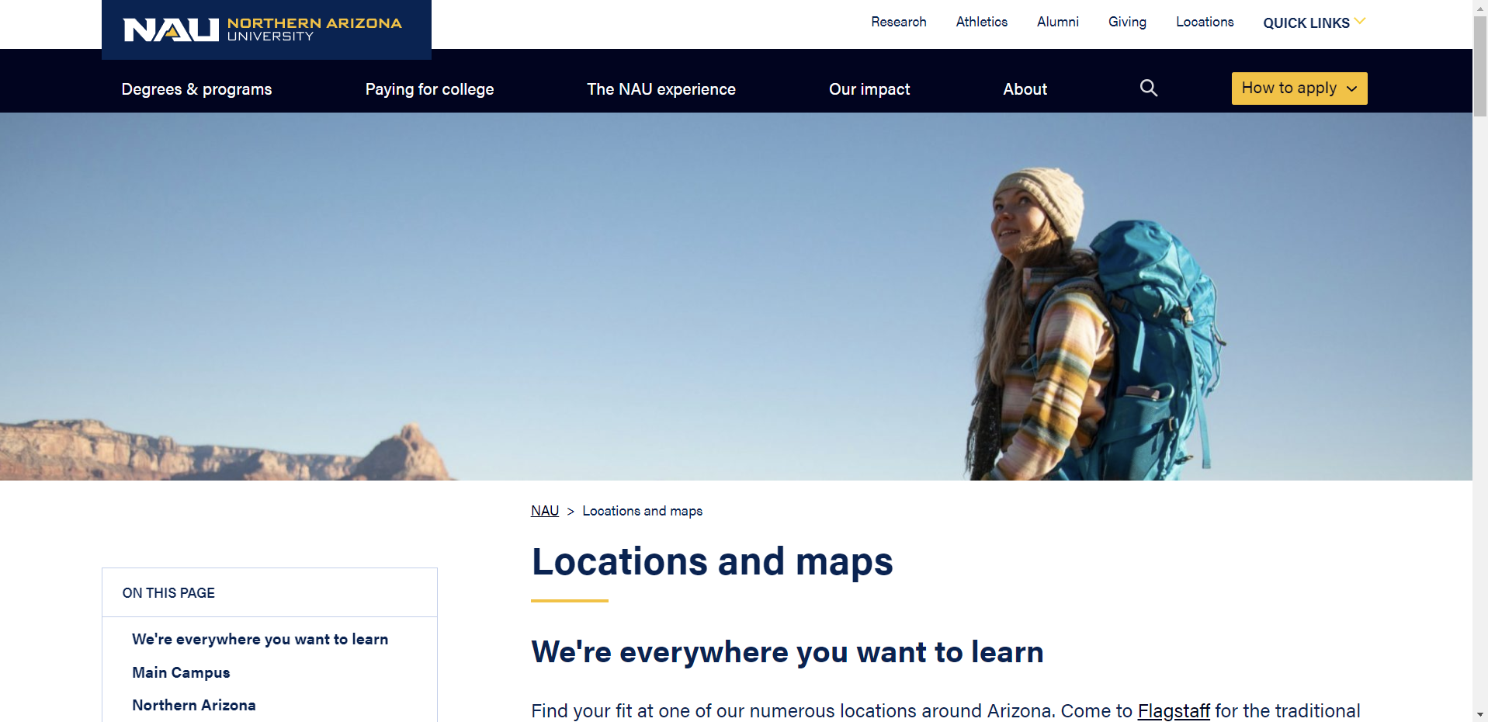

Fig (4.5)

**How to apply?**

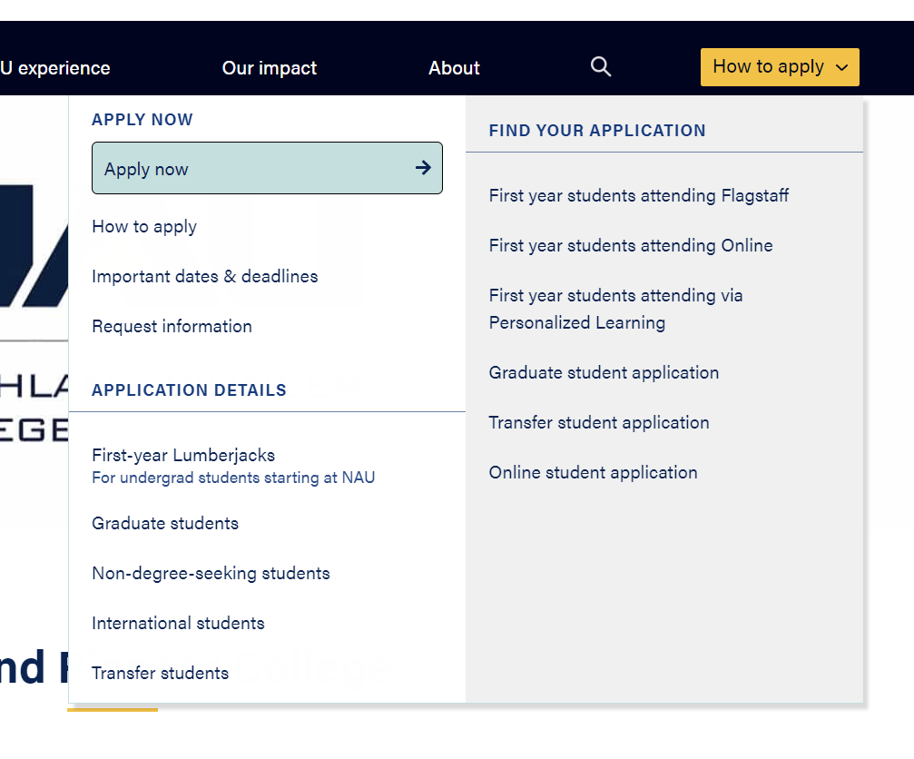

Fig (4.6)



Fig (4.7)



Fig (4.8)

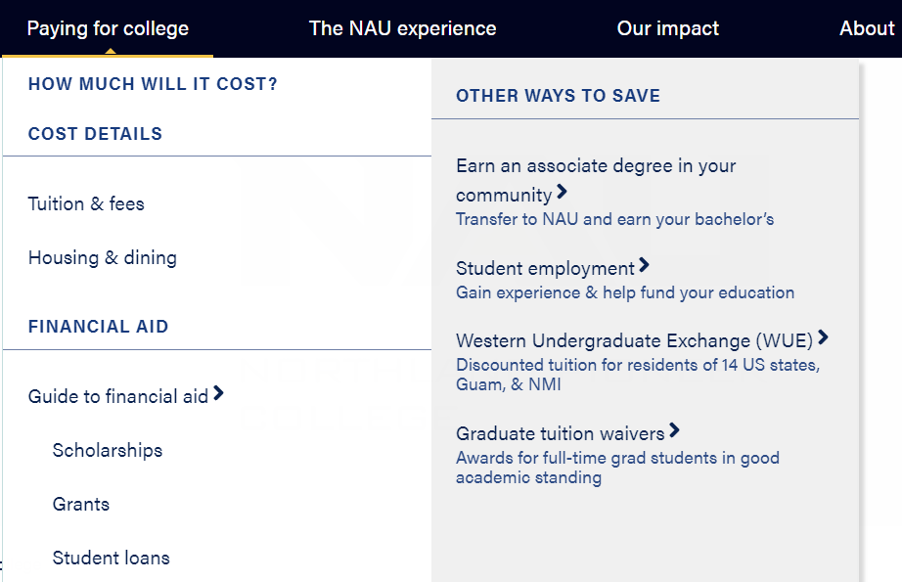

Fig (4.9)

**5.CONCLUSION**

The conclusion for development of NAU Academy website is that it is very convenient to users to get the information about NAU. Any one can access the website and can register with their details and can able get location of the college and about the college etc…. This application also helps how the NAU academy website is developed. Information about the NAU academy is provided in this document. To apply and to register or to know the details about NAU academy is provided.It is an interface or a medium to interact/contact with NAU academy. Contact form and Location details are provided.3

It is an easy way to share the information about colleges or it is a good way to make communication between the respected college and users/students. This is the best way to reduce the difficulty in contacting colleges by students.

**6.PROJECT OUTCOME**

Through this project I came across using VS-code. And we learn front-end development through HTML, CSS, JAVASCRIPT, Bootstrap and etc.…. Jpg images used in the development of website.CSS is used for presentation of the website.

**CODE LOCATION :**

**GITHUB :** <https://github.com/Kantubhukta-Hemanth/varshini>

**DEPLOYEMENT :** [**https://mvgr-cache.herokuapp.com/**](https://mvgr-cache.herokuapp.com/)

**REFERENCES**

1. https://www.w3schools.com/tags/tag_frame.asp
2. <https://in.nau.edu/the-academy/>
3. <https://en.wikipedia.org/wiki/Northern_Arizona_University>
4. [*"NAU – History"*](http://library.nau.edu/speccoll/exhibits/first100/nanframe.html). library.nau.edu. Nau.edu. [*Archived*](https://web.archive.org/web/20170211165131/http:/library.nau.edu/speccoll/exhibits/first100/nanframe.html) from the original on February 11, 2017*. Retrieved October 12, 2016*.
5. [**^**](https://en.wikipedia.org/wiki/Northern_Arizona_University#cite_ref-2) As of June 30, 2020. [*U.S. and Canadian Institutions Listed by Fiscal Year 2020 Endowment Market Value and Change in Endowment Market Value from FY19 to FY20*](https://www.nacubo.org/-/media/Documents/Research/2020-NTSE-Public-Tables--Endowment-Market-Values--FINAL-FEBRUARY-19-2021.ashx) (Report). National Association of College and University Business Officers and [*TIAA*](https://en.wikipedia.org/wiki/TIAA). February 19, 2021. [*Archived*](https://web.archive.org/web/20210221003510/https:/www.nacubo.org/-/media/Documents/Research/2020-NTSE-Public-Tables--Endowment-Market-Values--FINAL-FEBRUARY-19-2021.ashx) from the original on February 21, 2021*. Retrieved February 20, 2021*.
6. [**^**](https://en.wikipedia.org/wiki/Northern_Arizona_University#cite_ref-3) [*"Office of the President"*](http://nau.edu/president). Nau.edu. [*Archived*](https://web.archive.org/web/20210614095830/https:/nau.edu/president/) from the original on June 14, 2021*. Retrieved June 13, 2021*.
7. [**^**](https://en.wikipedia.org/wiki/Northern_Arizona_University#cite_ref-4) [*"Staff – Office of the Provost"*](http://nau.edu/Provost/Staff/). Nau.edu. [*Archived*](https://web.archive.org/web/20181119125642/https:/nau.edu/provost/staff/) from the original on November 19, 2018*. Retrieved July 17, 2021*.
8. [**^**](https://en.wikipedia.org/wiki/Northern_Arizona_University#cite_ref-Key_Statistics_5-0) [*"Facts – About NAU"*](http://nau.edu/About/Who-We-Are/Facts/). Nau.edu. [*Archived*](https://web.archive.org/web/20170313145836/http:/nau.edu/about/who-we-are/facts/) from the original on March 13, 2017*. Retrieved March 7, 2018*.